**Name : Abdul Basit**

**ID : CS231086**

**Course : Programming Fundamental**

TASK : 1

15 DEGREE CLOCKWISE DIRECTION

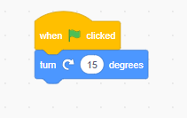

TASK : 2

CAT TO MOVE 50 STEPS

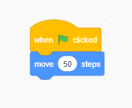

TASK : 3

SAY HELLO WORD FOR 1 SECOND

